Attachment 2
Paper Formatting Guidelines
The 2nd National and International Conference on Research and Innovation
“Innovation for Community and Society Development”
Institute of Vocational Education: Southern Region 3

Manuscripts submitted for consideration to IJICC must conform to the following
requirements that will facilitate the preparation of the article for publication:

Content | Font | Size | Style
Research Title | TH Sarabun PSK | 18 pt. | Bold
Name – Surname of researcher and co-researcher | TH Sarabun PSK | 14 pt. | Normal
Researcher’s information  - Department  - Institute / College  - Province  - Zip code  - E-mail  - Telephone number | TH Sarabun PSK | 12 pt. | Normal
Abstract | TH Sarabun PSK | 16 pt. | Bold
Content in the abstract | TH Sarabun PSK | 16 pt. | Normal
Keywords | TH Sarabun PSK | 16 pt. | Bold
Tittle  1. Introduction  2. Objective  3. Research hypothesis (If any)  4. Research methodology  5. Result  6. Conclusion  7. Conclusion and Recommendation  8. Reference | TH Sarabun PSK | 16 pt. | Bold
Content | TH Sarabun PSK | 16 pt. | Normal
หมายเหตุ 1. Using Microsoft Word 2013 or later.
2. Submit 2 files (1 *.docx and 1*.pdf).
3. Full paper not more than 10 pages, set layout margins as 1 inch and set
line space as 1 or single.
(Page Number)
(TH Sarabun PSK 18 pt. , Bold)

Research Tittle
(1 line, font 16 pt.)
Researcher¹
(middle, font 14 pt)
Researcher²
(1 line, font 8 pt.)
¹ Department / Major, Name of institute, Province, Zip code
(left, font 12 pt.)
In case of the researchers are in the same institute use ¹⁻²
² Department / Major, Name of institute, Province, Zip code

¹ Corresponding Author: E-mail: ...................................................

( 2 lines, font 16 pt.)
(middle, font 16 pt. bold)
Abstract
( Write clearly and concisely. Approximately 10 - 15 lines, divided into 2 paragraphs.
There are all the essentials in the research.)
(left
font 16 pt.)

Paragraph 1 Consists of research objectives, background, methodology, tools, data collection, sample, place of conducting data, statistics, and data analysis.
Paragraph 2 Summarize the results of the research and present guidelines for implementing the research results.
(left
font 16 pt. bold)
Keywords: Please specify keywords that are suitable for use as search terms in the database,
no more than 3-5 keywords.
(1 line, font 16 pt.)
(left, font 16 pt. bold)
1. Introduction
It is a topic that explains the reasons, and the necessity of conducting research, introducing broadly to see the problem. Point out or raise issues or limitations that arise. Offer information or solutions. Summarize the reasons and the necessity of conducting the research. Can be concluded from the background and importance of the problem in the research report.
(left
font 16 pt.)
- State the problem and development needs
- Study concepts/theories to solve problems or to develop
- Reference concepts/theories that are reliable.
- Propose ideas for solving problems that can be implemented.
(1 line, font 16 pt.)

2. Objectives
The message is short, concise, easy to read and understand. (Beginning with action verbs)
2.1 Consistent with background and research problems
2.2 Can clearly see the results that will occur.
2.3 The results that will occur can be used to solve problems.
2.4 It is a conclusion point or an important answer in the research.
(1 line, font 16 pt.)
3. Research hypothesis (if any)
Present the researcher's reasonably anticipated answers to the research problems using clear, easy-to-understand, and concise language.
(1 line, font 16 pt.)
4. Research Methodology
Present the process of conducting research. Explain the nature of innovations used in research, the steps of creating and developing innovations, and how to find the innovation’s quality before implementing.

4.1 Creation and development of innovation
4.2 Determine the population and sample correctly according to the research methodology.
4.3 Identify the research tools used in the research in its entirety.
1)
2)
4.4 Identify the process of creating and finding the quality of research tools based on academic principles.
1)
2)
4.5 Clearly state the details of the research and the method of data collection.
(1 line, font 16 pt.)

5. Result
Present research results according to research objectives. Briefing on data analysis and interpretation. Data analysis results should present the data using pictures. table or chart as well as there is an explanation of the meaning or content of the picture, chart, or table.
5.1 Present research results according to research objectives.
5.2 Present research results using pictures, charts, or tables.
5.3 There is a detailed description under the picture, chart, or table.

Presentation of research results using illustrations, including pictures, charts, and tables, line drawings, or photographs, with a resolution of at least 300 dpi. Characters appearing in the illustrations must be legible. Illustrations should fit the column. Inserting images should use images with sharp lines and legibility. Using very light tones will produce blurry prints. Illustrations and tables must include the number and name of the figure and chart and sort the number sequentially.

Examples of using illustrations
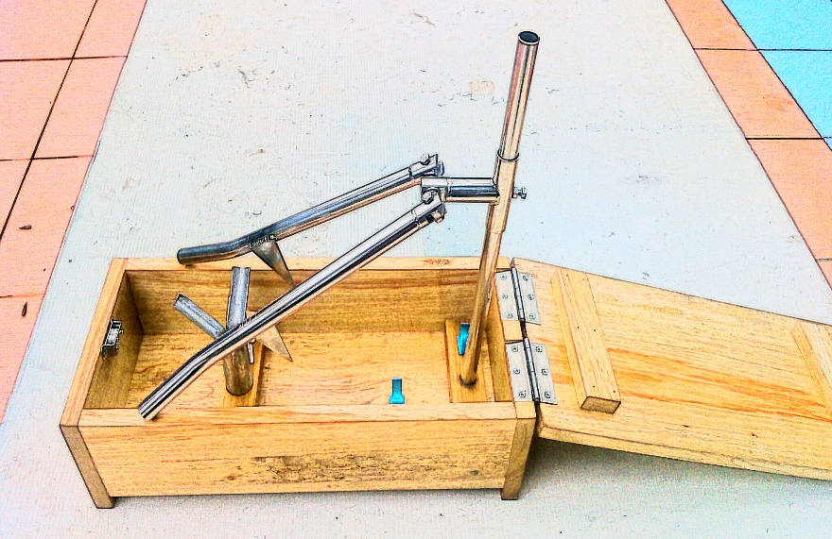
(bold)
(middle, font 16 pt.)
Picture 1 Knock Down durian peeling equipment

Example using the table
(left, font 16 pt.)
(left, font 16 pt., bold)

Table 1 Speed comparison of using knock down equipment traditional knife to peel durian
(Table head = font 14 pt., bold /
Data in the table = 14 pt.)
(1 line, font 8 pt.)
species | The speed of using a traditional knife  (Fruit/Mins) |  |  | Average  (Mins) | The speed of using Knock Down  (Fruit/Mins) |  |  | Average  (Mins) | Reduced speed  Average  (Mins) | Percentage
 | Fruit 1 | Fruit 2 | Fruit 3 |  | Fruit 1 | Fruit 2 | Fruit 3
Type 1 | 4.35 | 4.50 | 5.10 | 4.65 | 2.30 | 2.05 | 2.10 | 2.15 | 2.50 | 53.76
Type 2 | 3.05 | 3.30 | 3.40 | 3.25 | 1.25 | 1.10 | 1.20 | 1.18 | 2.07 | 63.59
Type 3 | 4.10 | 4.30 | 4.00 | 4.13 | 1.50 | 1.25 | 1.55 | 1.43 | 2.70 | 65.32
 | Total |  |  | 4.01 | Total |  |  | 1.59 | 2.42 | 60.39
(1 line, font 8 pt.)
From Table 1, it was found that the Knock Down durian peeler equipment was able to peel durian faster than using a traditional knife. The Knock Down durian peeling equipment used an average of 1.59 minutes per fruit. Traditional knife used an average of 4.01 minutes per fruit, with an average reduction of 2.42 minutes per fruit, representing an average of 60.39%.
(1 line, font 16 pt.)
6. Discussion
Discussing the findings is an important step because it is a research evaluation in order to give the reason to confirm that the research results are reliable and accurate by pointing out the consistency of the research hypothesis and theories.
(1 line, font 16 pt.)
7. Conclusion and recommendation
Conclusion
Summary of findings from the research which can be summarized according to the specified research objectives.
Recommendation
It is suggested that the results of the research can be applied rationally. It is a suggestion that can be used in future applications or further research.
1) ……….
2) ……….
(1 line, font 16 pt.)
8. Bibliography
- Writing citations in articles, write only those that are cited in the research article. Citations are written using numbering systems in research papers, always using consecutive numbers. by inserting the reference numbers in order from the number [1] onwards to be continuous. If there is a duplicate reference, use the same number that has been referenced before. To cite multiple documents at the same time, put the number of cited documents in order, separating each item with a comma (,) e.g. [3,4].
- Writing references at the end of the article, sort them by numbers [1] [2] [3]
-Reference topics such as 1. Books, 2. Translated books, 3. E-books, 4. Research reports, etc. do not need to be specified in the references.
- (/) means one space

APA Referencing (6th edition)

Author types
One author
Author, A. A./( year of publication)./ Title of book /(Edition)./ Location of publication:/ Publisher.
Two authors
Author, A. A., & Author, B. B./( year of publication)./ Title of book /(Edition)./ Location of publication:/ ////////Publisher.
Three authors
Author, A, A., Author, B. B., & Author, C. C./( year of publication)./ Title of book/(Edition)./
////////Location of publication:/ Publisher.
More than 7 Authors
Author, A, A., Author, B. B., Author, C. C., Author, D. D., Author, E. E., Author, F. F., &Author, G. G./
////////( year of publication)./ Title of book/(Edition)./ Location of publication:/ Publisher.

1. Book
Author, A. A./( year of publication)./ Title of book /(Edition)./ Location of publication:/ Publisher.
Example:
Tracy, B. (2014). Leadership (2nd ed.). New York: American Management Association.

No author
Title of book /(Edition)./ Location of publication:/ Publisher.
Example:
Leadership (2nd ed.). New York: American Management Association.

Book Chapter
Author, A./(year of publication). Title of chapter. In A. Editor & B. Editor(Eds.), Title of book (pp. xxx-xxx). ////////Location of publication: Publisher.
Example:
Zhou, H., & Chang, B. T. (2013). Strategies for success. In C. Taylor (Ed.), International students in
Australia (pp. 213-225). Melbourne: Monash University Press.

2. Translated book
Author, A./(year of publication)./ Translated title /[Original title]/( Translator name - first initial. last name, ////////Trans.)./Location of publication:/Publisher.
Example:
Ylinen, J. (2008). Stretching therapy: For sport and manual therapies (J. Nurmenniemi, Trans.). Edinburgh,
Scotland: Churchill Livingstone.

3. E-book
Author, A. A./(year of publication)./ Title of book /(Edition)./ Location of publication:/ Publisher.
Or
Author, A. A./(year of publication)./ Title of book /(Edition)./ doi:xxxx OR Retrieved from URL
Example:
Stevens, K. (n.d.) The dreamer and the beast. Retrieved from
http://www.onlineoriginals.com/showitem.asp?itemID=332
Jones, A.G., & Chen, B. (2015). Referencing: A guide for students (2nd ed.).
doi:10.1037//0022-006X.68.5.843

4. Research Report
Author, A. A./(year of publication)./Research Tittle./ Location of publication:/ Publisher.
Example
Tayama, T. (2006). Velocity influence on detection and prediction of changes in color and motion
direction. Sapporo, Japan: Psychology Department, Hokkaido University.

5. Thesis
Author, A. A./(year of publication)./ Title of thesis /(Unpublished doctoral dissertation or master's thesis). ///////Name of institution, Location.
Example:
Rahman, M. (2013). Using authentic materials in the writing classes: Tertiary level scenario. (Unpublished
master's thesis). BRAC University, Mohakhali, Dhaka, Bangladesh.

E-thesis
Author, A. A./(year of publication)./ Title of thesis /(Unpublished doctoral dissertation or master's thesis). ///////Name of institution, Location. Retrieved from http://www.xxxxxxxxx
Example
Axford, J.C. (2007). What constitutes success in Pacific Island community conserved areas? (Doctoral
dissertation, University of Queensland, Brisbane, Australia). Retrieved from
http://espace.library.uq.edu.au/view/UQ:158747

6. Journal
Print journal article
Author, A. A./(year of publication)./ Title of journal article/ Journal name, Volume(Issue), Page number(s).
Example
Lowrie, T., & Diezmann, C. M. (2009). National numeracy tests: A graphic tells a thousand words.
Australian Journal of Education, 53(2), 141-158.

E-Journal without DOI
Author, A. A./(year of publication)./ Title of journal article/ Journal name, Volume(Issue), Page number(s). ////////Retrieved from http: www.xxxxxx
Example
Fallon, A., & Engel, C. (2008). Hypertensive disorders of pregnancy. The Practising Midwife, 11(9), 1-27.
Retrieved from http://www.practisingmidwife.co.uk

E-Journal with DOI
Author, A. A./(year of publication)./ Title of journal article/ Journal name, Volume(Issue), Page number(s). //////// doi: xxxxxxxxx
Example
Osman, M. (2010). Controlling uncertainty: A review of human behavior in complex dynamic
environments. Psychological Bulletin, 136(1), 65-86. doi:10.1037/a0017815

7. Conferences papers and proceedings
Paper presentation in print proceedings
Author, A. A./(year of publication)./Title of session [Paper presentation]. In A. Editor, & B. Editor./
///////Title of Published Proceedings./(page numbers)./Location of publication:/Publisher.
Example
Piyasiripon, N. (2016). Factors affecting Policy Implementation Effectiveness toward National Security
Policy in Southernmost Provinces of Thailand. The 38th National Graduate Research Conference
(Humanities and Social Science) (pp. 169-176). Phitsanulok. Naresuan University Publishing House.
Online
Author, A. A./(year of publication)./ Title of conference paper./ Proceedings name./
///////Title of Published Proceedings./(page numbers)./ Volume(Issue),/Page number(s)./doi: xxxxxxxxx
Or
Author, A. A./(year of publication)./ Title of conference paper./ Proceedings name./
///////Title of Published Proceedings./(page numbers)./ Volume(Issue),/Page number(s)./Retrieved from ///////http://www.xxxxxxx
Example
Herculano-Houzel, S., Collins, C. E., Wong, P., Kaas, J. H., & Lent, R. (2008). The basic nonuniformity of the
cerebral cortex. Proceedings of the National Academy of Sciences, 105, 12593-12598.
doi:10.1073/pnas.0805417105

8. Website
Author, A. A./( Year page created or revised)./ Title of page/. Retrieved from http://www.xxxxxx
Example
Healey, R.G. (2011). The History of Policy Analysis. Retrieved 24 March 2019
from https://econ.duke.edu/uploads/media_items/what-is-the-history
-of-policy-analysis-9-2011.original.pdf

